Investing Notes
Christopher Kalitin

Brokerage Research

Went with CIBC. $100 / year fee waived for students. $7/trade free for 100 trades with EDGE100 promo until Sep 30 2026. No extra fee for currency conversion.

Questrade was second place. $0/trade, no account fees, also no extra currency conversion.

They rebate share transfer fees from other banks like CIBC, so CIBCs $150 out would be rebated if I transferred to them, but going out of Questrade has a $150 free.

https://grok.com/chat/c116d10b-d575-416d-876f-e907ccf6f64e

Now, what to invest in:
- Tesla Valuation Model V2
- Rocket Lab Valuation Model
- Compare to all other public space companies, see any promising ones and compare P/E (read that blog post on why P/E is stupid)
- Mix SPY/Nasdaq 100. I don’t see any issue putting it all into Nasdaq 100.

Allocation strategy
Any capital that will be needed in the next 1-2 years (eg. tuition) should be kept in safe investments (eg. SPY or NDX) or just in a high interest savings account (eg. 4%).

From a peak in 2022 to a minimum during the year SPY was down ~20% and NDX down ~30%. Baseline that anything invested here will be down 10% when you need it (20% is safer). For required payments (eg. tuition) use this 10% decrease as a baseline to plan how much cash must be kept.

Eg. for $8k tuition for year 2 IGEN, put $8.8k or $9.6k in SPY/NDX.

Leaning towards pure NDX currently:
SPY 5 year return is 95.31%, NDX is 116.82%

This illustrates that the -10% rule is for short term losses in the market, and is more pertinent for capital that will be withdraw in 1-2 years.

A couple of times both indexes were down ~20% over ~2-3 months, then recovered to the same level after ~5-6 months. COVID beginning and Trump getting elected. Sep 2018 for some reason too.

All capital that won’t be required in the next 1-2 years can be put into more risky investments. Eg. RKLB and TSLA.

Current cash: $13k CIBC, $1k cash.
Put that $1k cash into the CIBC account.

Assume $5k term 1 UBC, $3k term 2.

$5k will be required 6 weeks from now, $3k in 22 weeks.

I’ll go with 15%

$8k * 1.15 = $9.2k

Keep $1k for expenses in account

The rest of the 14-10.2 = 3.8 can be put into the companies.

Over a couple months dollar cost average into RKLB and TSLA, maybe 1-5 shares of RKLB for sentimental reasons (probably 1) all the rest in TSLA.

I effectively have 15% capital gains currently, so it’s not yet too painful.

Notes after opening accounts
CIBC doesn’t allow fractional shares

Questrade has a 1.5% currency conversion fee, both ways, net 3% loss.

Grok lied, should’ve doubled checked.

Can’t wait for the days when I don’t have to worry about currency conversion.

I need a standard operating procedure for investing.

Limit order: Buy at $X or better
Stop order: Once price reaches $X, buy at the next available price.

CAD ETFs Holding US Stocks
https://www.youtube.com/watch?v=IlSEg6Fux_A

TSX = Toronto Stock Exchange
VFV
- Tracks SPY in CAD on TSX
- Includes USD:CAD exchange rate
- Ie. Not hedged to exchange rate, that’s included in the price
- Wrapper of VOO, buys VOO directly
- 0.09% Annual Fees
- 15% lower dividend because of withholding taxes (USD to CAD tax immediately)

VOO
- Tracks SPY in USD on NYSE
- 0.03% Annual Fees
- No withholding tax since dividends transferred directly into your USD account
- USD:CAD exchange rate only applies when you sell in the end

- TFSAs get the 15% withholding tax, but RRSPs do not.
  - Can you not hold US ETFs in a TFSA?
- On blossom (Canadian stock social network), VFV is 3rd most held stock, VOO is held by 10x fewer people.

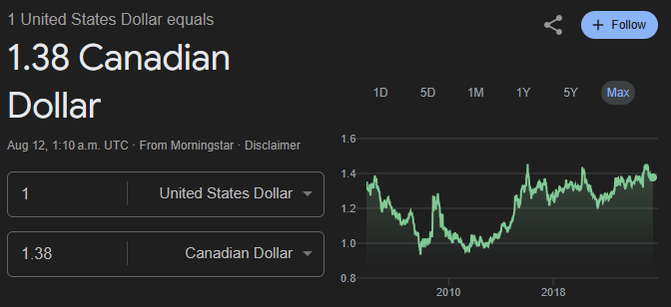

US Dollar has stayed roughly constantly since ~2016 (max 0.2 difference, on 1.4 thats 14% ok thats a lot).

When the Canadian dollar is strong compared to the US dollar, it’s a good time to buy. Ie. around 2011 you could’ve bought 1:1 and now it’s 1.38:1.

Either way, you get the exchange rate applied at purchase and sale of shares, so it doesn’t matter if you’re in VFV or VOO.

Now to find an NDX version, wait QQQ.

Norbert’s Gambit on Questrade
https://www.youtube.com/watch?v=q6Q1dzK8vts

- Use DLR.TO USD Currency ETF, it tracks the US dollar.
- DLR.U.TO is the USD version, DLR.TO is the CAD version.
- ECN fees are charged by the exchange, around 0.0035 $/share. If ~10k you start to notice.

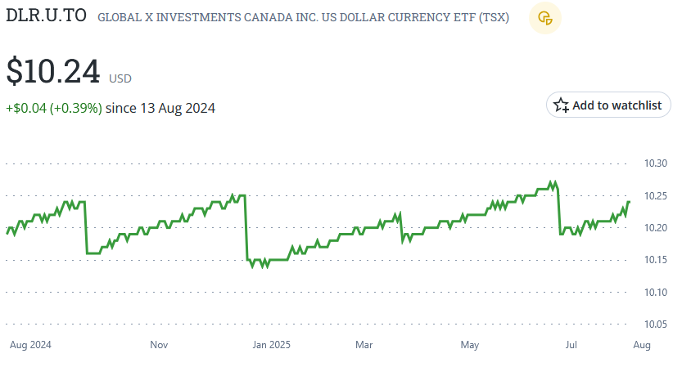

Strange negative spike at the end of every quarter in DLR.U.TO

Sep 26 -> 27, Dec 30 -> 31, Mar 28 -> 31, Jun 27 -> 30.
End of Q3, Q4, Q1, Q2.

Don’t do Norbert’s Gambit at the end of a calendar quarter!

They’ll actually just give you a dividend for the amount you lose, so it’s fine.

QQQ
- Tracks NASDAQ 100, equally weighted holdings
- 50% of it is in tech
- Expense ratio (annual fees) of 0.20%
- Traded in USD only
- NDX is a non-tradable benchmark, like the Russell 1000

SPY expense ratio is 0.0945%

TFSA Mistakes
https://www.youtube.com/watch?v=s4cBibLATOU

- Best savings account in Canada is EQ Bank at 1.25%, inflation is ~2% per year.
- GICs (Guaranteed Investment Certificate) give ~2% per year, 4 years ago
- So TFSA should be reserved for high return assets.
- In BC, Newfoundland, Nova Scotia, and New Brunswick you have to be 19 to open a TFSA account but start building room at 18.
- Withdrawals regain contribution amount but only on January 1 of the next year.
- To transfer TFSA accounts between banks, don’t withdraw then contribute (see above note, you’d need to wait to not max out contribution room for the year). Instead, do a transfer request through the bank you’re transferring into.
- Remember, Questrade reimburses transfer fees up to $150.
- If assets decline in a TFSA, you don’t regain contribution room.
- In a margin account you can claim a capital loss to reduce tax bill, but not in a TFSA.
- TFSA is only truly tax free for Canadian investments, hence the 15% withholding tax on US Dividends. US government automatically takes this 15% away.
- Due to US-Canada Tax Treaty, only RRSP, RRIF, and LIRA are exempt from US withholding taxes, not TFSA.
- Note capital gains are always 100% tax-free, just not dividends.
- Day trading is business income, not investment income, and is disallowed by the CRA.

VFV vs VOO

Parameters:
- 0.09% vs 0.03% fees
- ~$2 SPY Dividends per share per year (on $600/share)
- 15% withholding tax on VFV dividends (but not on VOO?)

Double checked management expense ratio, it’s correct: https://investor.vanguard.com/investment-products/etfs/profile/voo

Dividends are 0.33% per year. The withholding tax taxes this down by 0.000495% to 0.27% per year. 0.5% amount to $50/year on $10k. Significant enough to mention.

VOO is only exempt from withholding tax if held in an RRSP, otherwise it’s always applied.
This aligns with TFSA Mistakes research, I just didn’t put two and two together.
https://www.reddit.com/r/CanadianInvestor/comments/187hhxk/vfv_vs_voo/

So the only difference is the fees, which if I invested $10k (about what I will into SPY), would net out to $9 or $3. So completely insignificant.

And I won’t be opening an RRSP due to the lack of capital availability in it. Can’t transfer out until retired, it is a retirement savings account.

VFV vs VOO comes down to which currency you want to hold. VOO would require Norbert’s gambit so VFV is easier.

Attempting to buy VFV

- Day orders can’t be placed outside of trading hours.
- This caused my order to immediately fail, we’re 8 minutes after TSX trading hours (3 hour diff).
- Setting a limit buy above the current price makes it execute at any price below your limit.

QQC vs QQC.F - Currency Hedging

https://grok.com/chat/854c32b6-3380-4d4d-a4c8-f0435300a0c1

https://modernmoney.ca/investing/qqc-vs-qqc-f/

QQC and QQC.F both track the NASDAQ 100 (QQQ).

QQC is exposed to the CAD-USD exchange rate while QQC.F uses hedging to minimize currency exposure.

When I’m (me) buying the NASDAQ 100 I’m doing it because I expect the 100 most valuable companies list on the NASDAQ (~50% tech) to increase in value. This thesis has nothing to do with exchange rates and I do not care to learn about exchange rates for an extremely marginal increase in return. Hence, I don’t want exposure to the CAD-USD exchange rate.

Both:
- Expense ratio: 0.21%
- Dividend Yield: 0.47%
- Withholding Tax: 15%

QQC 3 year CAGR: 18.48%
QQC.F 3 year CAGR: 14.26%

HOLY FUCK WHAT, is this just due to the CAD-USD conversion rate?

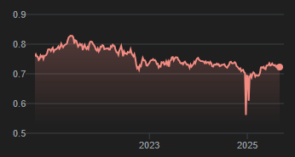

Over the last 5 years, CAD to USD rate has been decreasing. So, holding a security that is in raw US Dollars would give you a higher return.

Maybe part of my investment thesis is that the US economy is growing more than the Canadian economy, and hence the US dollar is growing stronger compared to CAD.

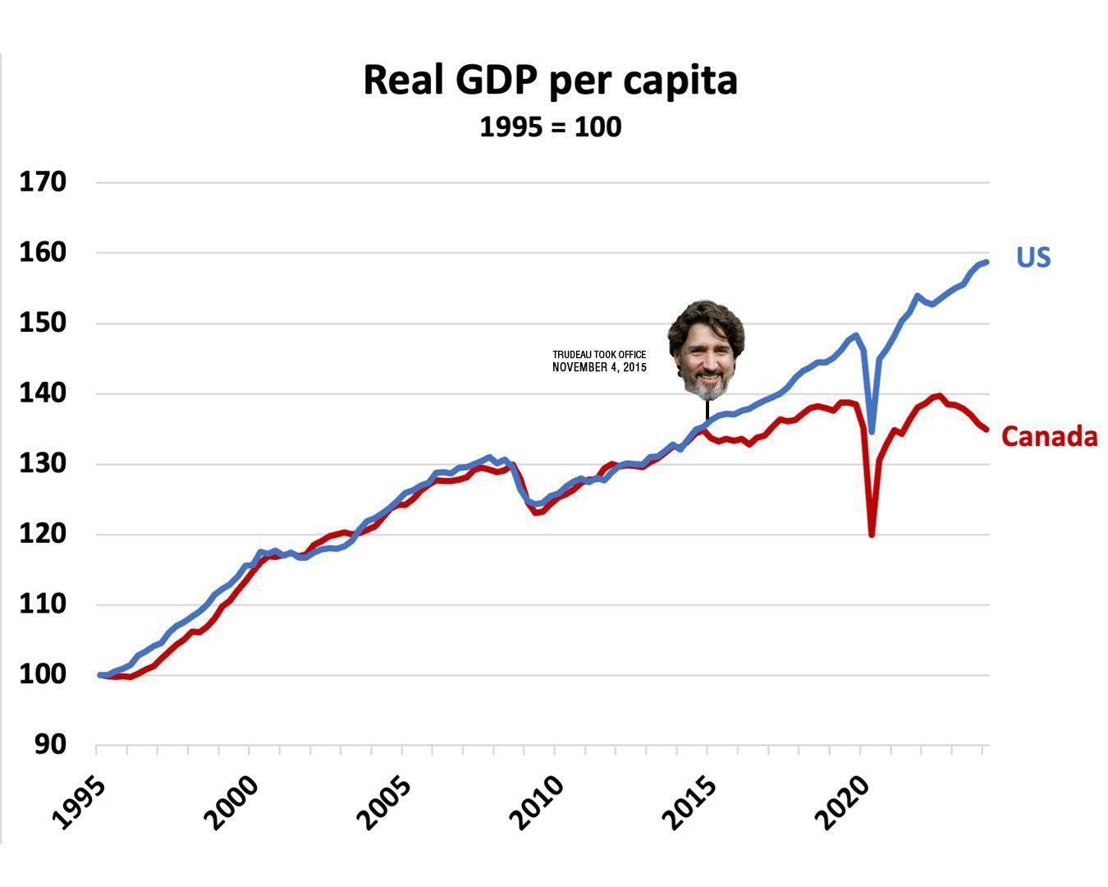

I’ve changed my mind. For an extra 4% CAGR, I’m more than happy to account for the CAD-USD exchange rate in my investment philosophy. This is not marginal.

So, QQC is what I should go with. QQC.F gives lower returns.

If GDP per Capita isn’t increasing, why are the Canadian markets appreciating? Are they? Net GDP is certainly increasing, how much of this is due to immigration leading to higher total productivity but not per-worker productivity?

I know how exposure to such questions, not a bad tradeoff.

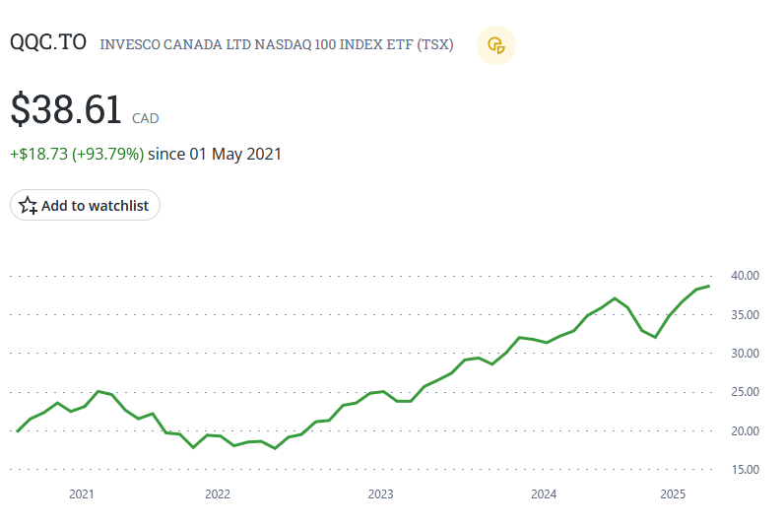

Note that both QQC and QQC.F were down ~30% from end of 2022 to end of 2023.

The chart above shows x-axis year markets in the middle of a year, not the beginning.

